
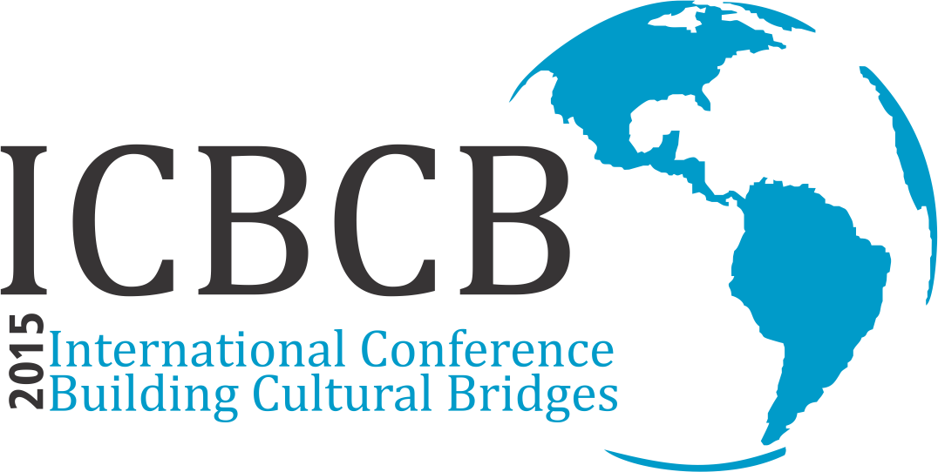

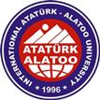great quote from the document or use this space to emphasize a key point. To place this text box anywhere on the page, just drag it.]
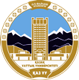
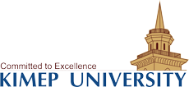

Call for Papers
2015 ICBCB Annual International Conference

7th International Conference, Building Cultural Bridges: Integrating Languages, Linguistics, Literature, Translation, Journalism, Economics and Business into Education

April, 23-24, 2015
Suleyman Demirel University
1/1 Ablaikhan Street
Karasai district, Kaskelen, Almaty
KAZAKHSTAN

ICBCB MISSION

Our mission is to promote intercultural tolerance and dialogue.

Suleyman Demirel University in partnership with the Academy of Public Administration under the President of the Republic of Kazakhstan, Al-Farabi Kazakh National University, KIMEP University and International Ataturk Alatoo University, Kyrgyzstan, invite the scholars, researchers and educators to the 7th International Conference, Building Cultural Bridges: Integrating Languages, Linguistics, Literature, Translation and Journalism into Education. The purpose of the conference is to focus on intercultural communication, peace and tolerance in culturally diverse communities, interfaith dialogue and tolerance, strengthening ties and links between different cultures, communities and countries via education. Also, the conference will create a good platform for the participants to establish fruitful cooperation sustaining academic mobility and research projects.
Conference events will include morning reception at our university, luncheon, coffee, tea and snack breaks. Our international guests will enjoy traditional Kazakh dinner and sightseeing of the city with a local guide.
We look forward to seeing you in Kazakhstan – the Land of Enchanted Horizons and Almaty city also known as the City of Apples.

SESSION TOPICS
- Lingua-cultural conceptology and cultural succession of generations
- Basic Dimensions and New Tendencies in Linguistics
- Contemporary Cultural Issues in Literary Studies: past, present and future
- Contemporary Topical Problems of Translation Studies
- Teaching Languages for Intercultural Communication: perspectives and opportunities
- Turkic Studies in the Context of Intercultural Dialogue: accomplishments and new concepts
- Topical areas of research in Contemporary Russian Language
- Communication and mass media: Between conflict and peace-building
- The Kazakhstani model of interethnic, tolerant and social harmony: significance, history and values
- Methodological Bases of Multilingual Educational System
- Technology assisted learning
- Contemporary issues of Post-Communist Central Asia
- Cultural issues in Business and Economic Research

Round Table discussion topics:
- Issues and perspectives of teaching and learning languages (SL, FL)
- Language identity and ethnic renaissance

IMPORTANT DATES
February 13, 2015 – abstracts submission deadline
February 27, 2015 – acceptance notification
March 06, 2015 – papers submission deadline

CONFERENCE FEES AND OTHER COSTS
Conference fee: $100 US dollars
Point of note: Participants who need a visa to enter Kazakhstan will have to pay extra $75 US dollars (10.000 tenge) for a visa support letter provided by Suleyman Demirel University.

CONFERENCE LANGUAGES: Kazakh, Russian, English and Turkish

ABSTRACT SUBMISSION
Similarly to the previous year, this year's conference proceedings will be published by a reputable publishing company and not the ones on Beall's list of predatory publishers. Submitted abstracts will go through the process of revision and evaluation for acceptance. Abstracts are due by February 13 for an early decision. Authors of accepted abstracts will be invited to submit a full paper by March 06. All submissions and inquiries should be directed to icbcb@sdu.edu.kz

PAPER SUBMISSION

Conference papers (not more than 10 pages (references included); A4 - size; designed in accordance with the template. The authors will have the full responsibility of accuracy and authenticity of their papers since they will be published as they are received without further proofreading and/or editing. Only the papers presented at the conference will be published in conference proceedings in digital format and the abstracts will be published in an extended abstract book. We take plagiarism issue very seriously. All submitted papers will be checked for plagiarism. Papers found to contain plagiarized material will be rejected.

A man becomes a person thanks to his intellect
Al Farabi (872-950 AD)

REGISTRATION FORM

- Name, Surname
- Affiliation/Department
- Country, city
- Passport Number
- Academic degree
- Address , zip code
- Phone / Fax
- E-mail
- Paper Title
- Session topic

